**NAME: M KISHORE ARVIND**

**Topics: Normal distribution, Functions of Random Variables**

1. The time required for servicing transmissions is normally distributed with *μ* = 45 minutes and *σ* = 8 minutes. The service manager plans to have work begin on the transmission of a customer’s car 10 minutes after the car is dropped off and the customer is told that the car will be ready within 1 hour from drop-off. What is the probability that the service manager cannot meet his commitment?
2. 0.3875
3. 0.2676
4. 0.5
5. 0.6987

ANS): Given to us :

i)Mean time (µ ) = 45 minutes.

ii)Standard Deviation of time ( σ) = 8 minutes.

In the problem, we are given that the service manager plans to begin work 10 minutes

after the car is dropped.

Also,we are told that the time required for servicing transmissions are Normally

Distributed.

So, we apply normal distribution from python and find out the value.

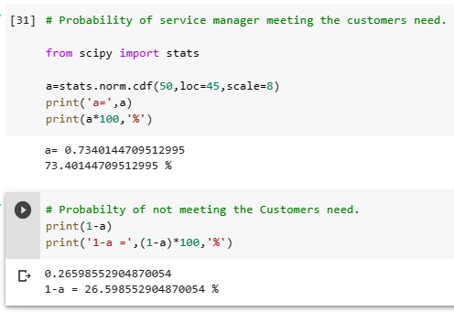

First , we find the probability of meeting the Customers need. It is found out to be 73.4%.

But, we need to find the probability of not meeting the needs is 26.59%, which is near to

0.2676.

From the options , we find the nearest value to be option (b).

* The probability of not meeting the needs is b) 0.2676.

1. The current age (in years) of 400 clerical employees at an insurance claims processing center is normally distributed with mean *μ* = 38 and Standard deviation *σ* =6. For each statement below, please specify True/False. If false, briefly explain why.
2. More employees at the processing center are older than 44 than between 38 and 44.
3. A training program for employees under the age of 30 at the center would be expected to attract about 36 employees.

ANS) : Given to us :

The current ages of clerical Employees are Normally Distributed .

1. mean ( µ) of 400 clerical employees = 38 .
2. Standard Deviation (σ) of 400 clerical employees = 6 .
3. No. of employees = 400.
4. Statement A states : That there are more employees at the processing center are older than 44 than between 38 and 44.

As they are Normally distributed , we use the norm.cdf function from scipy library.

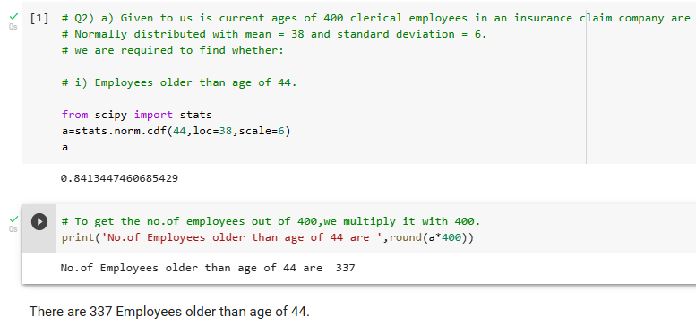

As we can see from the above screenshot that 337 Employees are older than the age of 44.

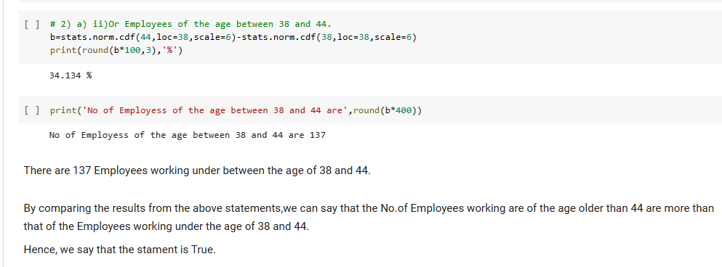

From the above screenshot, we see that the no. of Employees of the age between 38 and 44 are 137 Employees.

Hence, the statement is True.

B):Statement B: A training program for employees under the age of 30 at the center would be expected to attract about 36 employees.

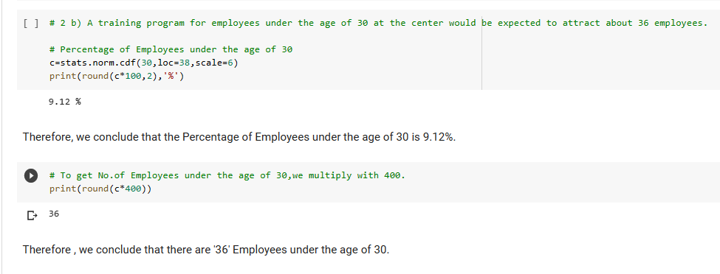

We just need to find the value at under the age of 30.So, by applying the formula of normal distribution from stats.norm.cdf , we have found out that the percentage is 9.12%.To the exact number of Employees, we need to multiply it with the total no.of Employees , which is 400.

We get 36 Employees working under the age of 30.

* Hence, we conclude that the statement is True.

1. If *X1*~ *N*(μ, σ2) and *X*2 ~ *N*(μ, σ2) are *iid* normal random variables, then what is the difference between 2 *X*1 and *X*1 + *X*2? Discuss both their distributions and parameters.

ANS): Given to us are two identical and independent random variables X1 and X2 , with ,

mean = µ , and variance = σ $^2$.

The Probability for Normal distribution for a Random Variable (X) is given as :

P(X) = [1 / √(2*π) * σ ] * e ^ [(X-µ)/σ]**2.

Parameters for the type kX random variable

For kX1 type :

Mean ( µ1 ) = k µ

Variance = k^2 v

Therefore ,

Mean = 2*µ

Variance = 2^2 var = 4*var

The distribution of this kind of normal random variable is Exponential in nature.

Parameters for the type X1+X2 type random variable.

For X1 + X2 type :

Mean ( µ2 ) = µx1 + µx2

Standard deviation (σ2) = (k1^2 + k2^2)v

The distribution of this kind of random variable is linear in nature.

1. Let X ~ N(100, 202). Find two values, *a* and*b*, symmetric about the mean, such that the probability of the random variable taking a value between them is 0.99.
2. 90.5, 105.9
3. 80.2, 119.8
4. 22, 78
5. 48.5, 151.5
6. 90.1, 109.9

ANS) Given to us is the Normal Random variable ‘X’ with mean = 100 and standard deviation = 20.

We need to find two values , a,b such that the probability of random variable ‘ X‘ is 0.99.

We shall go by the options and find out the answer:

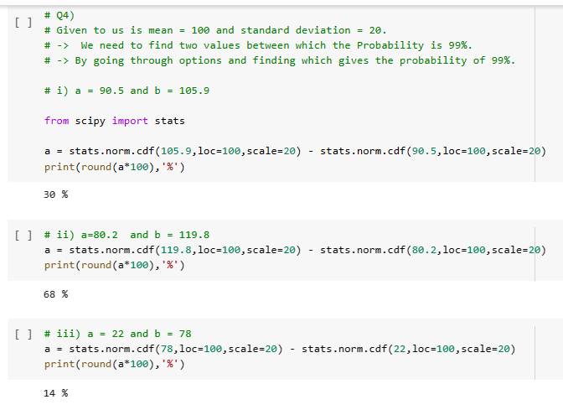

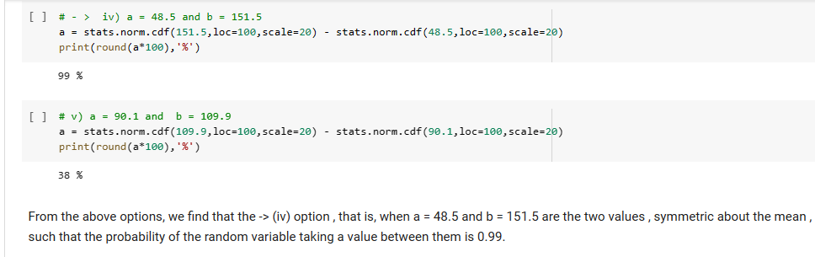

From the above options, we find that iv) option 48.5 and 151.5 which gives a probability of 99% is the right answer.

1. Consider a company that has two different divisions. The annual profits from the two divisions are independent and have distributions Profit1 ~ N(5, 32) and Profit2 ~ N(7, 42) respectively. Both the profits are in $ Million. Answer the following questions about the total profit of the company in Rupees. Assume that $1 = Rs. 45
2. Specify a Rupee range (centered on the mean) such that it contains 95% probability for the annual profit of the company.
3. Specify the 5th percentile of profit (in Rupees) for the company
4. Which of the two divisions has a larger probability of making a loss in a given year?

ANSWER): -> A) Given that a company has 2 different divisions.

* The annual profits are normally distributed.

We know that a Normal Distribution of a random variable ‘X’ has the notation N(µ,σ^2) . The Probability of Normal Distribution is given as below:

P(X) = [1 / √(2*π) * σ ] * e ^ - [(X-µ)/σ]^2.

The Profit Profit1 has Mean 1 = 5 and standard deviation 1 = 3.

The Profit Profit2 has Mean 2 = 7 and Standard Deviation 2 = 4.

Std Error = standard deviation / (n)**0.5

Here, n=2 since given 2 different companies.

Population mean = (sample mean1 + sample mean2) / 2

= (5+7)/2 = 6

Population Standard Deviation = [[(5-6)^2 + (7-6)^2]/2] ** 0.5

= 1

Standard Error = 1 / √2 = 0.707

t_95% = 1.984

Lower_Limit = 6 - (1.984 * 0.707) = 4.597

Upper_Limit = 6 + (1.984*0.707) = 7.402

These are in $.We need to convert them into Rs by multiplying with 45.

Lower_Limit = 4.597 * 45 = 206.865

Upper_Limit = 7.402 * 45 = 333.09

Therefore, we conclude that in a range of Rs 206.865 to 333.09 , 95% of the probability occurs.

ii) 5th percentile of profit is :

= ( 5/100) * [(Upper_Limit – Lower_Limit)/ (Lower_Limit) ]

= 0.05 * (333.09-206.865)/(206.865)

= 0.05 * 126.225

= 3.05

Therefore, the %th percentile of the profit is Rs 3.05.

iii)The 2nd division with mean = 7 and standard deviation = 4 is able to make higher loss than the first one.